Space Debris Problem

Space debris is a big problem. The satellite which are in the space and are near to end of their life, they just remain their and taking up necessary space as they are getting piled up. The satellites may also collide with the other space satellites or objects there by creating a more debris. So the solution for this problem is that we have created a graveyard orbit. Since the existing satellite don’t have the propulsion system due to which they cannot change their orbit and therefor they keep on going in the same orbit even after the end of their life. The exisiting orbit for the satellite is pre-define and may me Low earth Orbit( LEO) or Geo synchrounous orbits.

By using the equation Gm1m2/r2  so here radius ( r) cannot be changed.Due to which they keep on revolving in the same orbit even after their end of life.

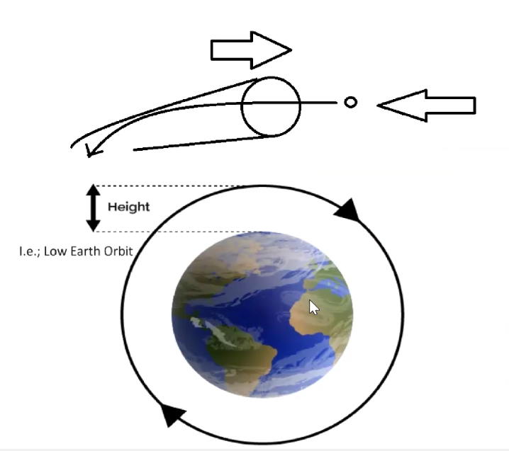

We have solution in which we have used a de-orbital tunnel (physical tunnel) having big open mouth( more than 20 feet in diameter) with the slightly curved end or the end if the de-orbital tunnel is slightly curved. So what will happen is like, any space debris which will enter the tunnel such that the rear end of the tunnel which is slightly curved( narrow and curved towards the earth) due to which the direction of the space debris will start changing towards the earth. After it comes and collide in the tunnel , it will change its direction towards the earth as the debris hit the inner boundary of the curved tunnel. Now as the debris hits the inner boundary of the tunnel, the momentum of the debris gets changed thereby changing its orbit.

Now what will happen is, one the debris is out of the pre-defined , now it will come towards the earth , the earths gravity will do the rest. The earth will just pull it and burn it due to high friction because of gaining speed because of de-orbiting. The moment debris enters into the earth orbit they heat up and got burnt and melt.

The way we installed the Internation space station , a space station having the size almost equal to size of 3 football fields. So it could be that kind of exercise to install a de-orbital tunnel in the space.

When the space debris enters into the tunnel, due to principal of conservation of momentum, the tunnel will also be deflection slightly. So after every collision of the curved tunnel with the space debris we have to make sure that the tunnel is oriented back to it original position. So for that we have a innovative solution of Flywheel mechanism. (three dimensional flywheel). This flywheel actually converts the angular momentum in the linear momentum and is used by satellite to orient.

The satellite uses the three-dimensional fly wheel mechanism to orient themselves. This flywheel has a motor and a weight, with the computer system it will calculate by how much it has to orient it and then it will orient it back to its original position. The flywheel will be run by motor and the motor will be powered by solar panels as the tunnel always have a solar supply in the space.

